Table of Contents
1.0 Investigational Site Personnel Role 1
1.1 Access eDA via the Study Portal 2
1.2 Basic Navigation 3
1.3 Manage the Device Filter 3
1.4 Confirm Device Receipt 5
1.5 Reporting Device Usage 6
1.6 Recording Device Returns 6
1.7 Reporting Discarded/Scrapped Devices 8
1.8 Printable eDA Log Reports 9
1.8.1 PDF File Output 10
1.8.2 Excel File Output 11

Investigational Site Personnel Role
Investigators or designated research staff members are responsible for device control and device accountability at the clinical site during the clinical study. To support this activity the eDA Log serves three primary functions:
- Provides the clinical site with an interface to record receipt of investigational devices (acknowledge receipt of device shipments);
- Provides the clinical site with an interface to record return of investigational devices (confirm site return, date returned and courier tracking number);
- Provides the clinical site with an interface to record comments regarding device disposition when devices are not returned or used during study procedures; and
- Displays recorded device uses as indicated via electronic Case Report Form (CRF) completion by the clinical site.
Note: The eDA Log serves as the official device disposition record for the study. Paper logs should not be maintained or filed separately. It is permissible to print, use the device log outputs for review or verification purposes but printed records are not considered the official device record and these will not be collected or monitored by Abbott.

Access eDA via the Study Portal
Directions | Screen Shot
1. Navigate to website and enter login credentials. | 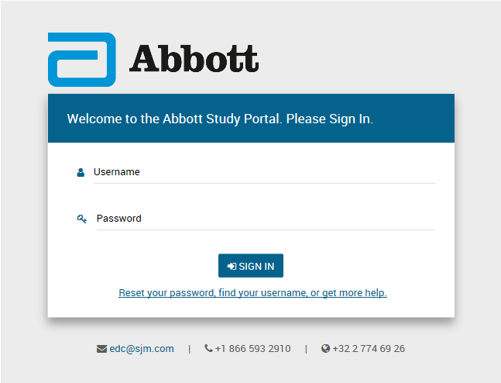
2. After the window refreshes, select Device Log from the navigation bar on the left, and then select the appropriate study from the list that appears. | 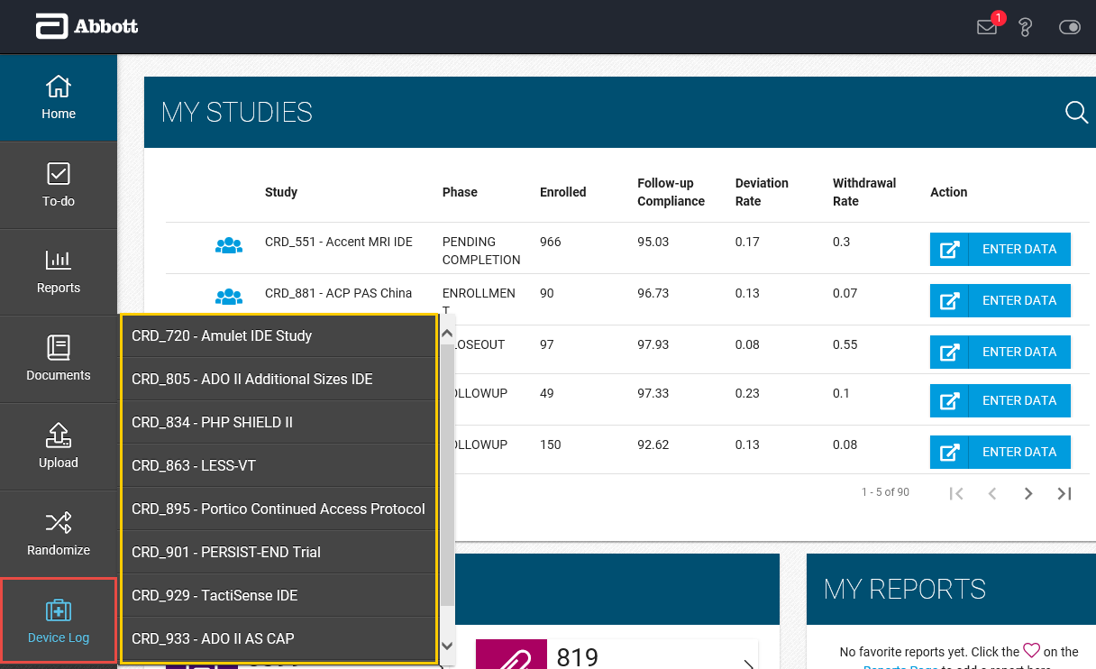
4. The eDA Log will open and display the default filtered view for site staff. | 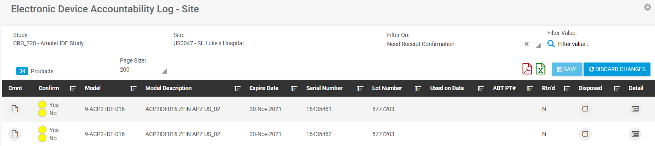

Basic Navigation
The eDA Log will load device transactions for the study selected at time of initial login and the default view is filtered to display devices which require shipment receipt confirmation:
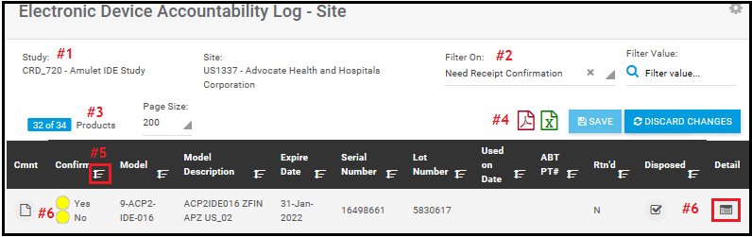
- “Study” (displays based on selection at time of Study Portal login; if site participates in more than one Abbott study) and “Site” Information (displays only for site based on login info);
- “Filter On” function that can be cleared (to see all devices) or reset to desired display;
- Total “Products” displays (blue highlight) the comprehensive tally of all devices associated with the site for the selected study;
- Icons for “PDF” and “Excel” file data exports:
  - The PDF will format/display eDA in a “traditional” device log format for viewing and printing, if desired.
  - The Excel report will export all device transaction details into an excel format that can be filtered, sorted or otherwise managed for desired device review activities.
- This is the “Header Row” for the device log and most of the columns have a Ascending/Descending Sort option: which may be used to sort by the column of interest.
- Each row under the header row displays information regarding individual devices (serialized as well as Lot/Batch controlled devices). Selected information is displayed in this view with additional details specific to each device available by selecting the “Detail” button on the far right row of interest.

Manage the Device Filter
The eDA Log can be filtered to display all transactions or just those of particular interest.
Directions | Screen Shot
1. To remove the filter (and see all transactions), locate the filter and click the “x” to view all devices. | 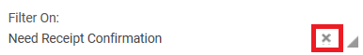
2. If another filter is desired, click the drop down arrow and select the filter of interest. | 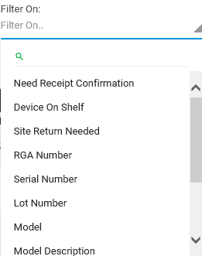
3. Depending on the filter selected, additional detail will need to be entered to the right.  Note: “Need Receipt Confirmation”, “Device on Shelf” and “Site Return Needed” filters do not require Filter Value. | 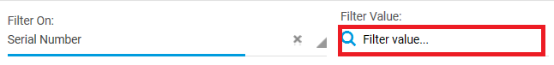
4. The eDA Log will refresh and display the desired details based on the specified filter criteria.

Confirm Device Receipt
Capturing confirmation of device receipt by Site Users is a primary function of the eDA Log and should be performed routinely after receiving a device shipment. The Abbott clinical study team should proactively notify the receiving sites of device shipment(s).
Directions | Screen Shot
1. Ensure the applicable study and site is displayed. | 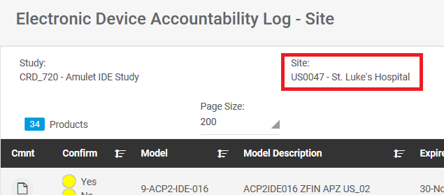
2. Ensure the filter is set to “Need Receipt Confirmation.” | 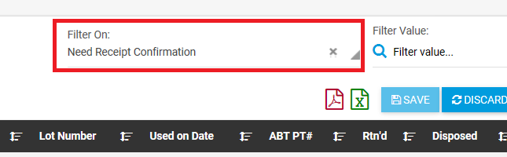
3. Confirm received devices:  (a) Review received inventory by comparing the eDA Log to packing lists and physical inventory;  (b) Select “Yes” for devices received;  (c) Select “No” for any devices that were not received and contact the Abbott clinical study team;  (d) If any materials are received that are not listed on the eDA Log or packing lists, contact the Abbott clinical study team. | 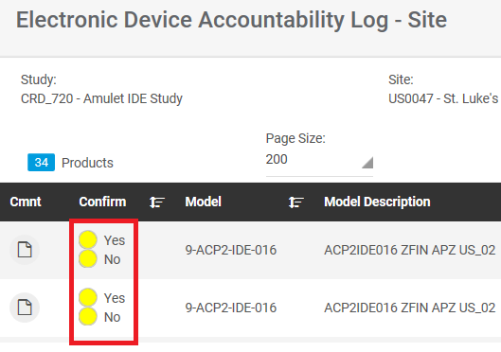
4. If there are any comments to share, click on the paper icon in the “Cmnt” column for the affected device. Comments can be especially helpful if:  - any devices are not received; or  - Extra devices are received (i.e. materials not on the eDA log). | 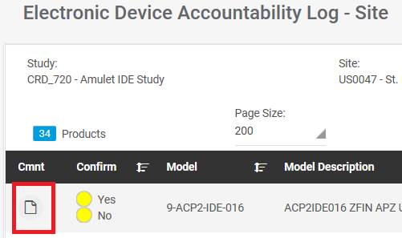

Reporting Device Usage
To report device(s) used, implanted, or otherwise assigned to a study subject, please complete the appropriate electronic CRF. Devices opened but not used are generally reported via a Product Out of Service CRF, if available for the study. Usage data (and any subsequent corrections) from the electronic CRF will be visible within the eDA Log after overnight refresh. No device “usage” is entered manually into the eDA Log.

Recording Device Returns
Contact the in-house study team to return investigational devices. The Rtn’d flag will change on the eDA Log in the following scenarios:
Flag | Definition
 | No Return Requested
 | Return has been Requested and Return Goods Authorization (RGA/RMA) Number has been obtained (appears as R in the pop-up window after clicking this icon)
 | Site Return Sent (appears as S in the pop-window after clicking the yellow unchecked box)
 | Return Received by Abbott (overnight refresh required)

To record the Site return, follow the steps below:

Directions | Screen Shot
1. Ensure the applicable study and site is displayed.
2. Ensure the filter is set to “Site Return Needed.” | 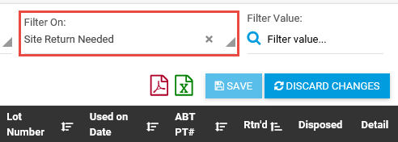
3. Click on the empty checkbox with the yellow background in the Rtn’d column for a device that was sent back to Abbott. | 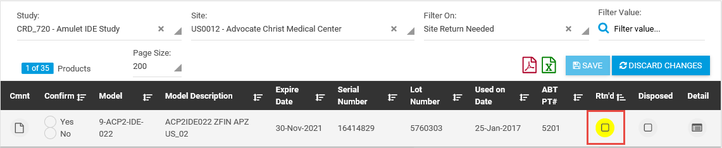
4. A pop-up will appear for all products assigned to the same RGA as the product selected. For each product that was returned:  (a) Select “Yes” in the Returned column;  (b) Date Sent will default to today’s date. Update the date if the return was sent in the past.;  (c) At the top of the pop-up window, add the Tracking Number associated with this return. If there is already a tracking number from another return listed, append a semi-colon (;) and the new tracking number to the end;  (d) Click “Save”. | 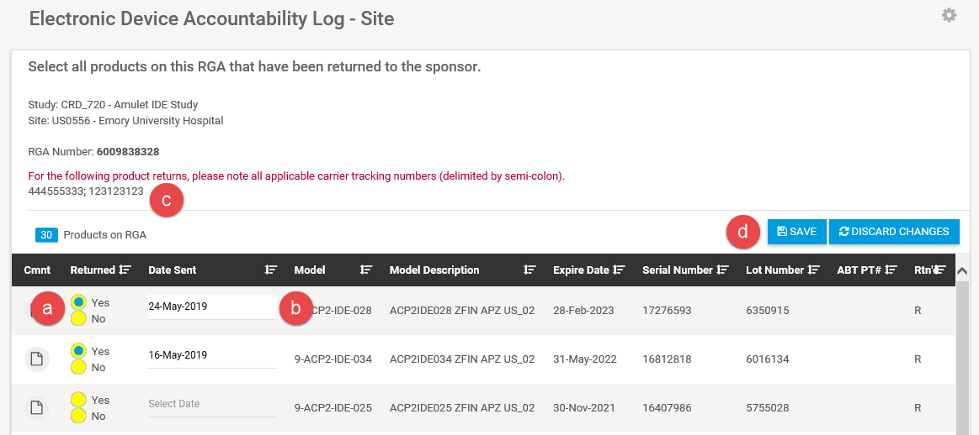
5. If there are any comments to share, click on the paper icon in the “Cmnt” column for the affected device. | 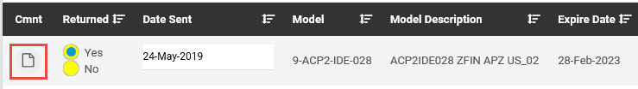

NOTE: To support this activity, it is helpful to include the return shipment forms (provided separately by the Abbott clinical study team) and write any Return Goods Authorization (RGA/RMA) numbers on the outside of the return shipment box.

Reporting Discarded/Scrapped Devices
All unused investigational devices should be returned to Abbott. There are occasions where investigational devices are not returned, e.g. lost device, device inadvertently opened and discarded. In these cases this information should be manually entered into and captured on the eDA Log; see steps below. Depending on the circumstances, additional investigation and documentation may be required.
Single-use, disposable investigational devices (i.e. delivery/loading systems, catheters) that have been used on a study subject without any associated complaint(s) do not need to be reported as “disposed” on the eDA Log nor returned to Abbott unless specified in the Clinical Investigational Plan.

Directions | Screen Shot
1. Find the affected device; the search filter is useful to find the device. | 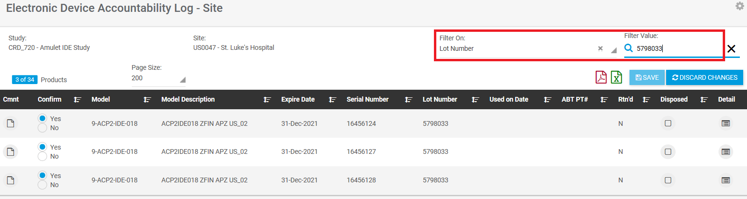
2. Click the box in the “Disposed” column for the affected row, a pop up window will appear. | 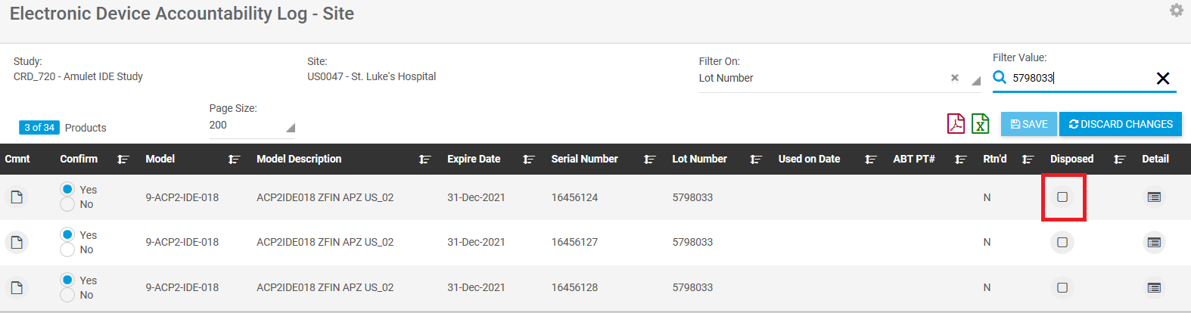
3. The purpose of this window is to confirm that the selected device was discarded and comments are required to complete this update. | 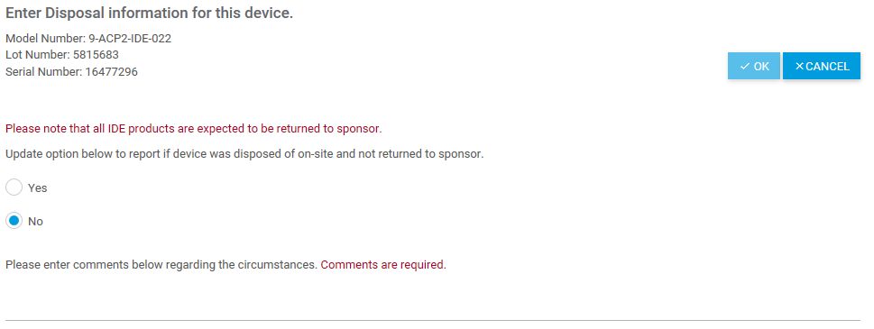
4. Start by selecting “Yes.” The default is set to “no”. Enter comments/explanation in the “comments“ field. When finished, click on “OK”. | 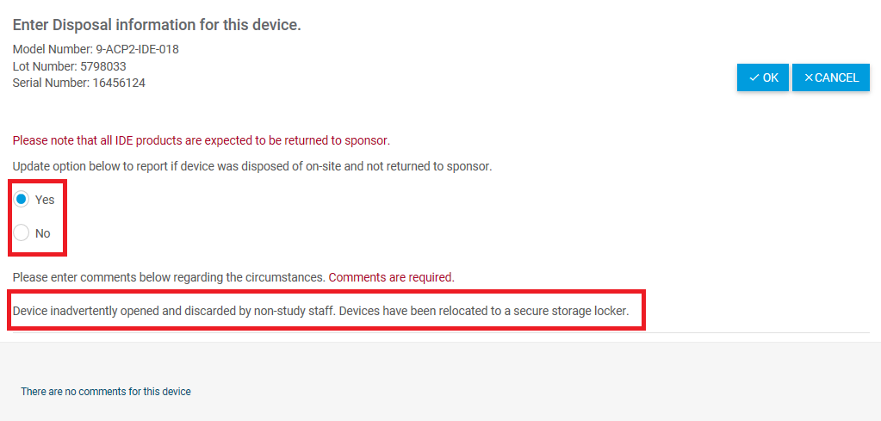
5. Optional (as needed); if a device has been reported as disposed in error, return to step #2 to select the device. The pop up window will appear, select “No” and provide comments. Note that prior/historical comments are saved and displayed at the bottom of the pop up window. | 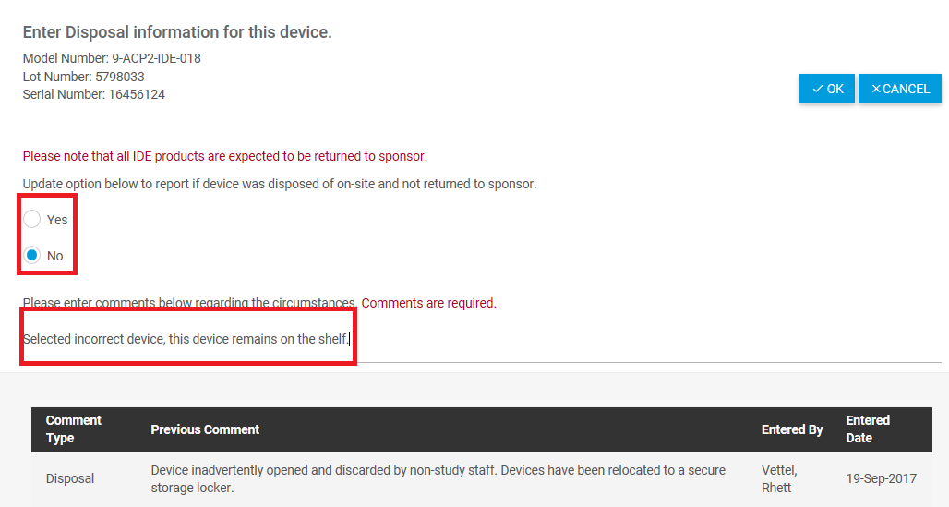

Printable eDA Log Reports
During the course of the study it may be desired to print the eDA Log. The Log can be printed in two different formats based on user preference.
Note: the “printed” eDA Logs are “snapshots” in time and only current/accurate on the date of creation/printing. Abbott recommends against keeping these records in any regulatory binder/files.
To create a report, select the icon of preference and the system will generate the report. Your system or internet connection may affect the speed in which the report is created; the selected icon will “spin” until the report is generated:
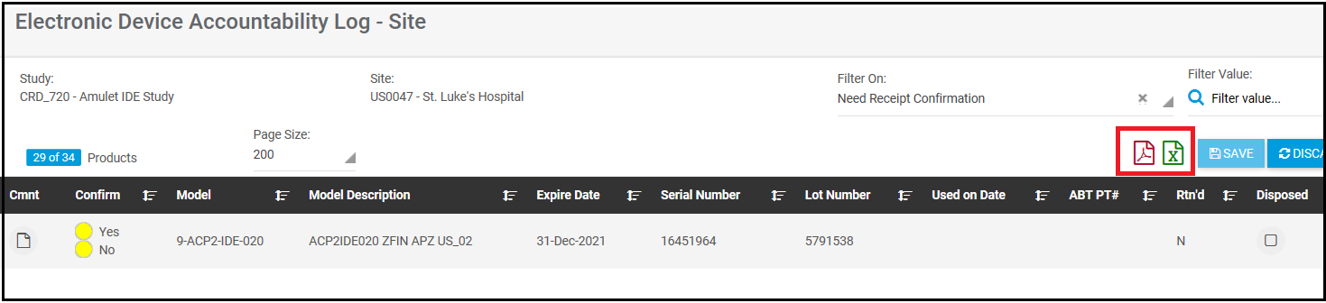

PDF File Output
When printed, this report resembles a “traditional” device log. It will display the “print date” which will correspond to the date of creation. The most current version of adobe may be required to support viewing. Sample of the output is below:
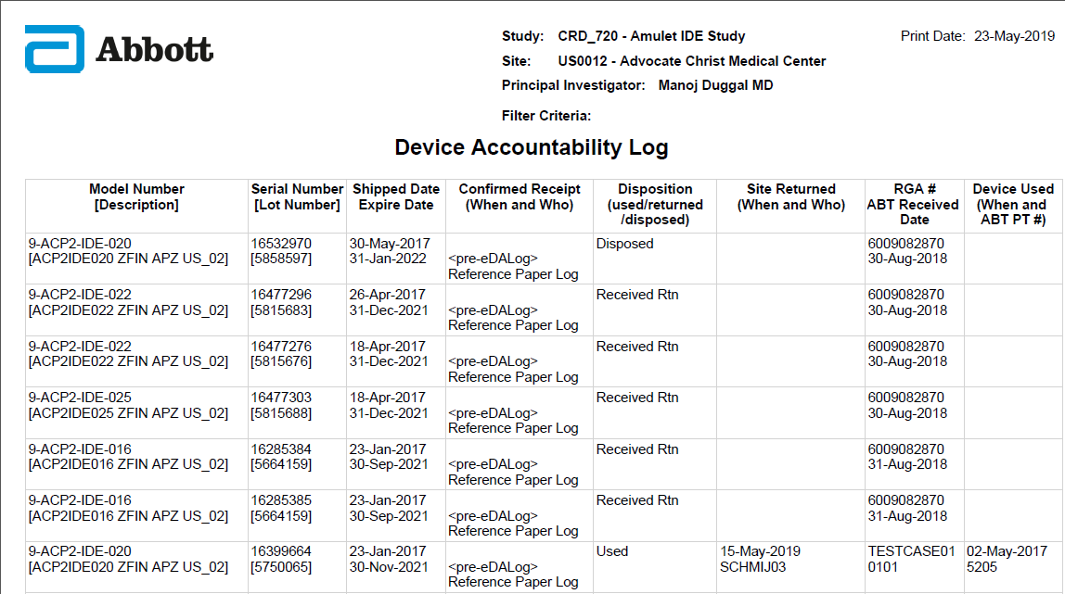

Excel File Output
When selected, this report exports all device details into an Excel report with all the functionality of Excel. i.e. columns can be hidden, removed, or filters can be applied. A sample of the raw output is below:

